**Name: Poorna Pallavi Tekkali**

**Part -1**

**1.Domain-Modelling Brainstorming:**

Full-time employee. Full-time employees1 work 40 hours a week 5and are typically paid on a salary basis1 (or gross income2) that does not change during the year. They may also have access to benefits7 provided by the company8, like healthcare coverage 3and 401(k)5. The payroll 5for a full-time employee1 is computed by using the following formula:

Period pay=(gross income - healthcare deduction - 401(k) 5deduction) * (1 - tax withholding rate)  
where gross income, healthcare deduction, 401(k)5 deduction and tax withholding rate are different for different employee1.

 Part-time employee. Part-time employees 1usually work less than 30 hours per week 5and are paid hourly 8.

The payroll 5for a part-time employee 1is calculated as follows:

Period pay=hourly rate 8* hours worked 5* (1 - tax withholding rate)  
where hourly rate, hours worked and tax withholding rate 6 are different for different employees 1.

 Contract employee. Contract employees 1are hired for a specified period of time 9 outlined in a contract 5. The number of working hours for a contract employee may vary for each contract, but they are not limited to 40 hours per week 5. The payroll 5for a contract 5 employee 1 is computed as follows:

Period pay=contract total/(contract period/length of pay interval 5)  
where contract total and contract period are different for different contract employees 1, and the length of pay interval 5 is assumed to be monthly 5

For example, if the contract total is $240,000 and the contract period 5 is 2 years, then the period pay or monthly pay 5is  
Period pay=$240,000 / (24 months / 1 month) = $10,000

**2.Classifying brainstorming result:**

|  |  |  |
| --- | --- | --- |
| Brainstorming list | Classification list | Rule |
| Full time employee | (C)Full time employee Employee working 40 hours/week with fixed gross income. | 1(a) |
| Part time employee | (C)Part time employee- A paid hourly worker who puts in less than thirty hours each week. | 1(a) |
| Contract employee | (C)Contract employee- Employee engaged for a predetermined amount of time as per a contract. | 1(a) |
| Gross Income | 1. Gross Income- total income earned by the employee before deductions. | 1(a) |
| Helath care | 1. Health care- benefits that the business offers, like as health insurance. | 1(a) |
| Tax withholding rate | 1. Tax withholding rate- percentage of income subject to tax withholding. | 1(a) |
| Hourly rate | 1. Hourly rate-Rate per working hour | 1(a) |
| Working hours | 1. Working hours-Number of hours worked | 1(a) |
| Contract period | 1. Contract period Rate per hour for workers who work part-time. | 1(a) |
| Total Contract | 1. Contract total- Total contract value for an employee under contract. | (C) |
| Period pay | 1. Period pay- Payroll is calculated using particular formulas for every kind of employee. | 3 |
| Benefits | 1. Benefits- Extra benefits or privileges offered by the business. | (C) |
| Company | 1. Company- the company where the worker is employed. | (C) |
| Average Period pay | (AC) Average period pay- Calculation of the average payroll for each employee type. | 1(e) |
| Range periods pay | (AC) Range period pay- the range of payroll for every kind of employee is calculated. | -1(e) |
| Database manager | 1. Database manager- oversees the archiving and access of personnel records. | -(C) |
| Length of pay interval | 1. Length of pay interval- Pay calculations assume a monthly duration. | 5(b) |
| Application | (AC)Application- software used in the computation of average and range period pay. | -(C) |
| Buttons clicked | (AC) Buttons clicked- actions that start the application's processes. | -7(a) |
| Display results | (AC) Display results-Output shown | -1(e) |
| Total employees | (AG) Total employees- total number of workers in the company. | -1(e) |
| Full time type employee | (C)Full time type employee- Full-time status is indicated by the employee subtype. | -7(a) |
| Part time type employee | (C)Part time type employee- Part-time status is indicated by the employee subtype. | -7(a) |
| Average Pay type | (C)Average Pay type- A subtype of computation that shows the mean salary. | -(C) |
| Range calculation | (C)Range calculation- Range calculation subtype of a calculation. | -7(a) |

**3.Domain model class diagram:**

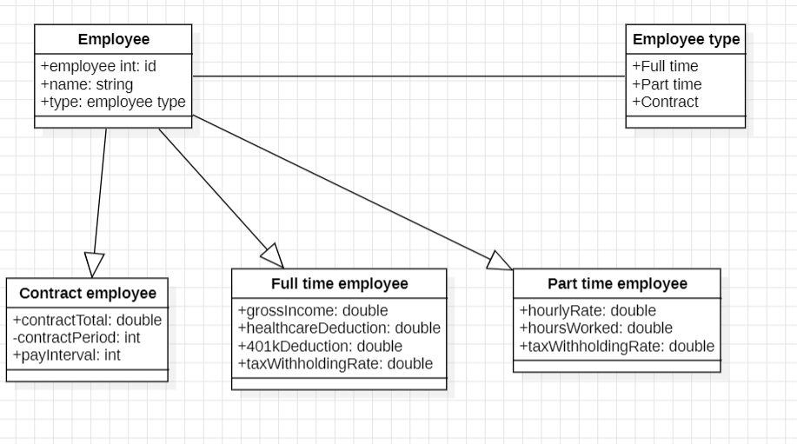

**4.UML CLASS DIAGRAM:**

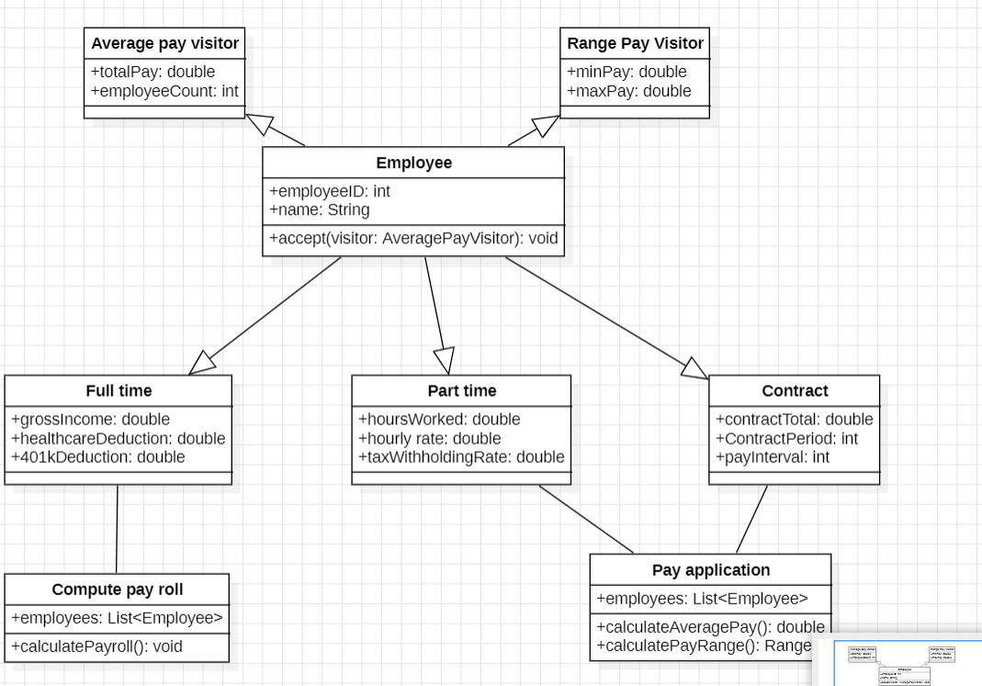

**5.Scenario**

**Payroll Application Using Iterator and visitor patterns**

**1.Intilization:**

Comprising full-time, part-time, and contract workers, the payroll management system has a group of workers.

EmployeeCollection employeeCollection = new EmployeeCollection()

**2.Setting Visitors:**

The average period pay and pay range for various employee kinds are computed using two visitors that are instantiated: AveragePayVisitor and RangePayVisitor.

AveragePayVisitor averagePayVisitor = new AveragePayVisitor();

RangePayVisitor rangePayVisitor = new RangePayVisitor()

**3.Iteration for employee:**

To go through the group of workers, regardless of their kinds, an iterator is utilized.

EmployeeIterator iterator = employeeCollection.createIterator()

**4.** **How to Determine Average Pay:**

The AveragePayVisitor is applied for every employee. It computes the mean period salary for every category of employees while keeping track of the total and the count.

public double getAverageFullTimePay() {

return fullTimeCount > 0 ? totalFullTimePay / fullTimeCount : 0;

}

public double getAveragePartTimePay() {

return partTimeCount > 0 ? totalPartTimePay / partTimeCount : 0;

}

public double getAverageContractPay() {

return contractCount > 0 ? totalContractPay / contractCount : 0;

}

**5.** **Compute Pay Range:**

After the iterator is reset, the minimum and maximum pay for each employee type are tracked using the RangePayVisitor to determine the pay range.

iterator.reset();

while (iterator.hasNext()) {

Employee employee = iterator.next();

employee.accept(rangePayVisitor);

}

Range fullTimePayRange = rangePayVisitor.getFullTimePayRange();

Range partTimePayRange = rangePayVisitor.getPartTimePayRange();

Range contractPayRange = rangePayVisitor.getContractPayRange();

**6.Displaying results:**

The computed average pay and pay range for every category of employee can now be seen or used by the system.

"Full Time: $" + rangePayVisitor.getMinFullTimePay() + " - $" + rangePayVisitor.getMaxFullTimePay()

+ "\n" +

"Part Time: $" + rangePayVisitor.getMinPartTimePay() + " - $" + rangePayVisitor.getMaxPartTimePay()

+ "\n" +

"Contract: $" + rangePayVisitor.getMinContractPay() + " - $" + rangePayVisitor.getMaxContractPay()

+ "\n"

**6**.**Implement your design:** 